Name : عبدالرحمن محمد سالم حسن section : 1 BN : 38
LAB2
Student experiment 1:
- y[n]=x[n]-x[n-1]-x[n-2]
Linearity:
x₁[n] -> y₁[n] = x₁[n] - x₁[n-1] - x₁[n-2]
x₂[n] -> y₂[n] = x₂[n] - x₂[n-1] - x₂[n-2]
A.y₁[n] + B.y₂[n] = A.(x₁[n] - x₁[n-1] - x₁[n-2]) + B(x₂[n] - x₂[n-1] - x₂[n-2]) -> (1)
x₃[n] = A.x₁[n] + B.x₂[n] -> y₃[n] = x₃[n] – x₃[n-1] – x₃[n-2]
y₃[n] = A.x₁[n] + B.x₂[n] - A.x₁[n-1] - B.x₂[n-1] - A.x₁[n-2] - B.x₂[n-2] -> (2)
since (1) = (2) then y₃[n] = A.y₁[n] + B.y₂[n] then the system is linear.
Time Invariance:
x₁[n] -> y₁[n] = x₁[n] – x₁[n-1] – x₁[n-2] -> y₁[n-n₀] = x₁[n-n₀] – x₁[n-n₀-1] – x₁[n-n₀-2]
x₂[n] = x₁[n-n₀] -> y₂[n] = x₁[n-n₀] – x₁[n-n₀-1] – x₁[n-n₀-2]
since y₂[n] = y₁[n] then the system is time invariant.

y[n]=cos(x[n])
Linearity:
x₁[n] -> y₁[n] = cos(x₁[n])
x₂[n] -> y₂[n] = cos(x₂[n])
A.y₁[n] + B.y₂[n] = A.cos(x₁[n]) + B.cos(x₂[n]) -> (1)
x₃[n] = A.x₁[n] + B.x₂[n] -> y₃[n] = cos(x₃[n])
y₃[n] = cos(A.x₁[n] + B.x₂[n]) -> (2)
since (1) = (2) then y₃[n] $≠$ A.y₁[n] + B.y₂[n] then the system is nonlinear.
Time Invariance:
x₁[n] -> y₁[n] = cos(x₁[n]) -> y₁[n-n₀] = cos(x₁[n-n₀])
x₂[n] = x₁[n-n₀] -> y₂[n] = cos(x₁[n]-n₀)
since y₂[n] = y₁[n] then the system is time variant.

y[n]=nx[n]
Linearity:
x₁[n] -> y₁[n] = nx₁[n]
x₂[n] -> y₂[n] = nx₂[n]
A.y₁[n] + B.y₂[n] = A.nx₁[n] + B.nx₂[n] -> (1)
x₃[n] = A.x₁[n] + B.x₂[n] -> y₃[n] = nx₃[n]
y₃[n] = n(A.x₁[n] + B.x₂[n]) -> (2)
since (1) = (2) then y₃[n] = A.y₁[n] + B.y₂[n] then the system is linear.
Time Invariance:
x₁[n] -> y₁[n] = nx₁[n] -> y₁[n-n₀] = (n-n₀).x₁[n-n₀]
x₂[n] = x₁[n-n₀] -> y₂[n] = n.x₁[n-n₀]
since y₂[n] = y₁[n] then the system is time variant.

- y[n]=x[n]-x[n-1]-x[n-2]
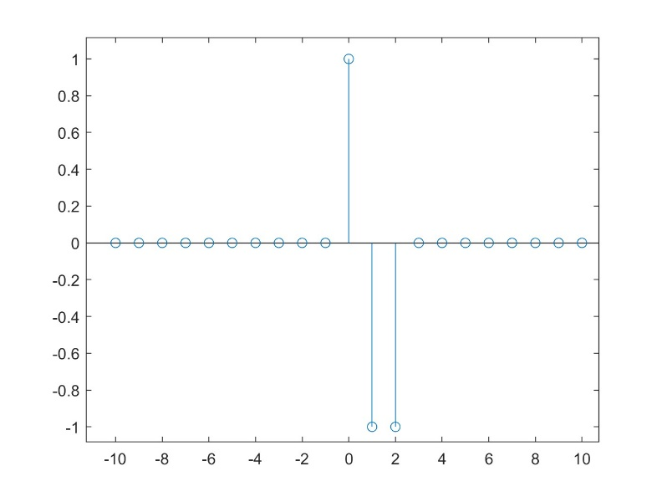
input = Delta(n) response
>> nx1=[-10:10], x1=[zeros(1,10) 1 zeros(1,10)];
>> y = zeros(1,length(x1));
>> for c=3:length(x1)
y(c) = x1(c)-x1(c-1)-x1(c-2)
end
>> stem(nx1, y)

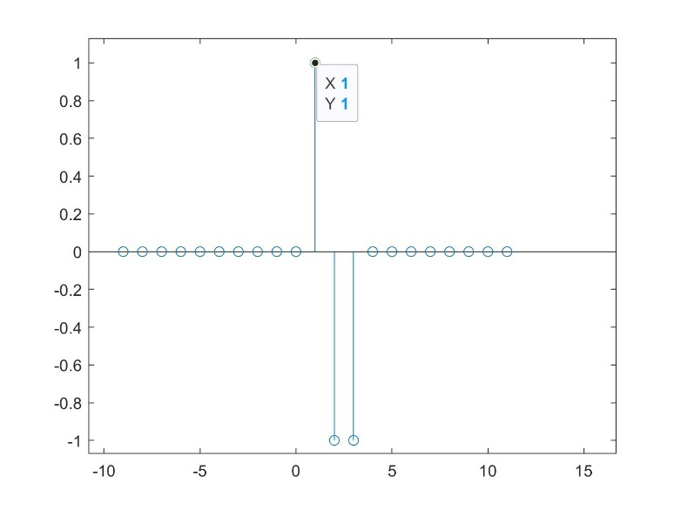
input = Delta(n-1) response
>> nx1=[-10:10], x1=[zeros(1,10) 1 zeros(1,10)];
>> y = zeros(1,length(x1));
>> for c=3:length(x1)
y(c) = x1(c)-x1(c-1)-x1(c-2)
end
>> stem(nx1+1, y)
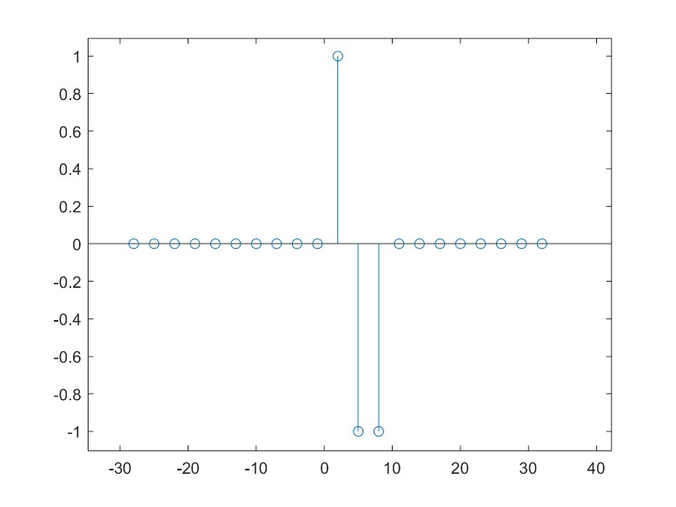
input = Delta(n)+2* Delta(n-1) response
>> nx1=[-10:10], x1=[zeros(1,10) 1 zeros(1,10)];
>> y = zeros(1,length(x1));
>> for c=3:length(x1)
y(c) = x1(c)-x1(c-1)-x1(c-2)
end
>> stem(nx1+2*(nx1+1), y)

y[n]=cos(x[n])
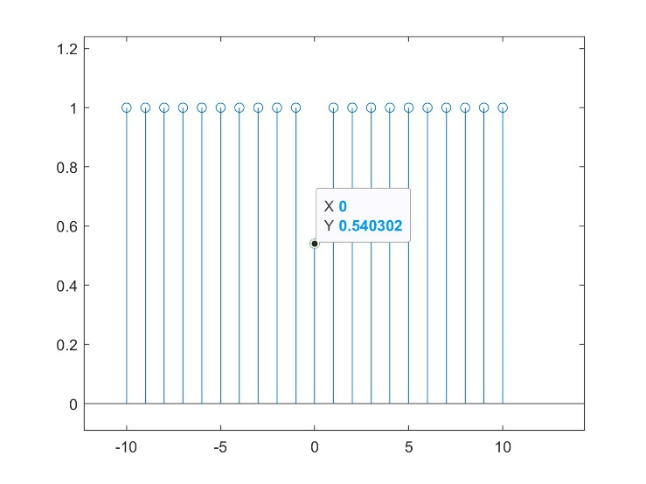
input = Delta(n) response
>> nx1=[-10:10], x1=[zeros(1,10) 1 zeros(1,10)];
>> y = zeros(1,length(x1));
>> for c=1:length(x1)
y(c) = cos(x1(c));
end
>> stem(nx1 ,y)

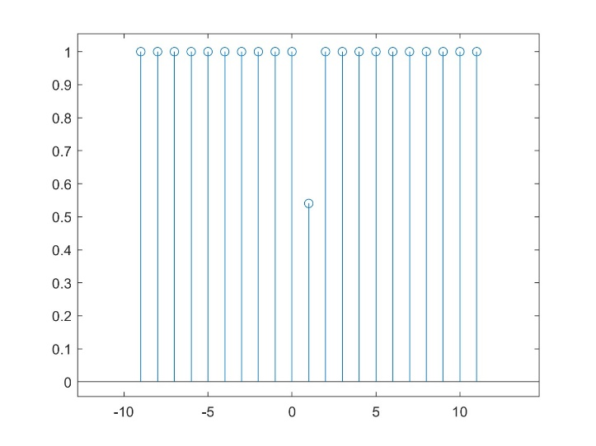
input = Delta(n-1) response
>> nx1=[-10:10], x1=[zeros(1,10) 1 zeros(1,10)];
>> y = zeros(1,length(x1));
>> for c=1:length(x1)
y(c) = cos(x1(c));
end
>> stem(nx1+1 ,y)

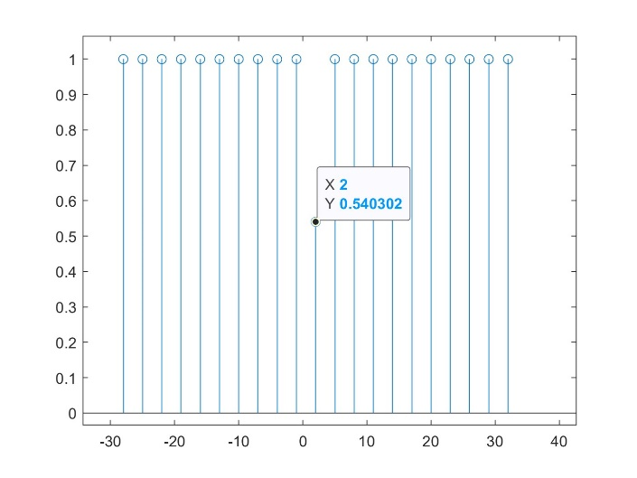
input = Delta(n)+2* Delta(n-1) response
>> nx1=[-10:10], x1=[zeros(1,10) 1 zeros(1,10)];
>> y = zeros(1,length(x1));
>> for c=1:length(x1)
y(c) = cos(x1(c));
end
>> stem(nx1+2*(nx1+1), y)

y[n]= nx[n]
input = Delta(n) response
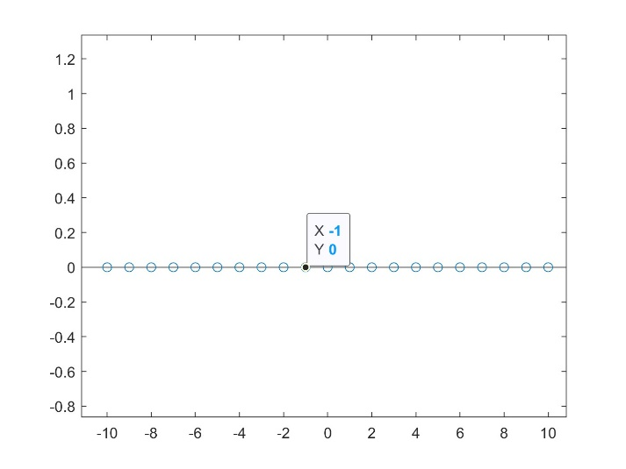
>> nx1=[-10:10], x1=[zeros(1,10) 1 zeros(1,10)];
>> y = zeros(1,length(x1));
>> for c=1:length(x1)
y(c) = nx1(c) * x1(c)
end
>> stem(nx1,y)

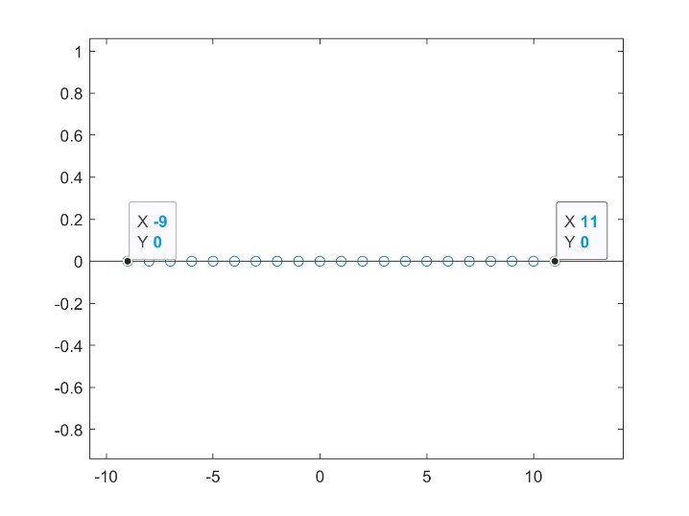
input = Delta(n-1) response
>> nx1=[-10:10], x1=[zeros(1,10) 1 zeros(1,10)];
>> y = zeros(1,length(x1));
>> for c=1:length(x1)
y(c) = nx1(c) * x1(c)
end
>> stem(nx1+1 ,y)

input = Delta(n)+2* Delta(n-1) response
>> nx1=[-10:10], x1=[zeros(1,10) 1 zeros(1,10)];
>> y = zeros(1,length(x1));
>> for c=1:length(x1)
y(c) = nx1(c) * x1(c)
end
>> stem(nx1+2*(nx1+1), y)
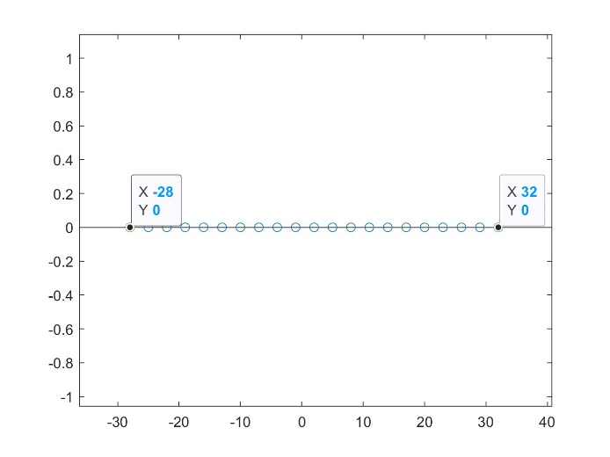

Student experiment 2:
>> nx=[-3 -2 -1];
>> x =[1 2 3];
>> nh=[-6 -5 -4 -3 -2 -1];
>> h =[9 8 5 32 5 3];
>> M=length(x);
>> N=length(h);
>> ny=[-9:-2]
>> y=zeros(1,M+N-1);
>> for u=1:(N)
x1=h(u)*[zeros(1,u-1) x zeros(1,length(y)-u-2)];
y=y+x1;
end

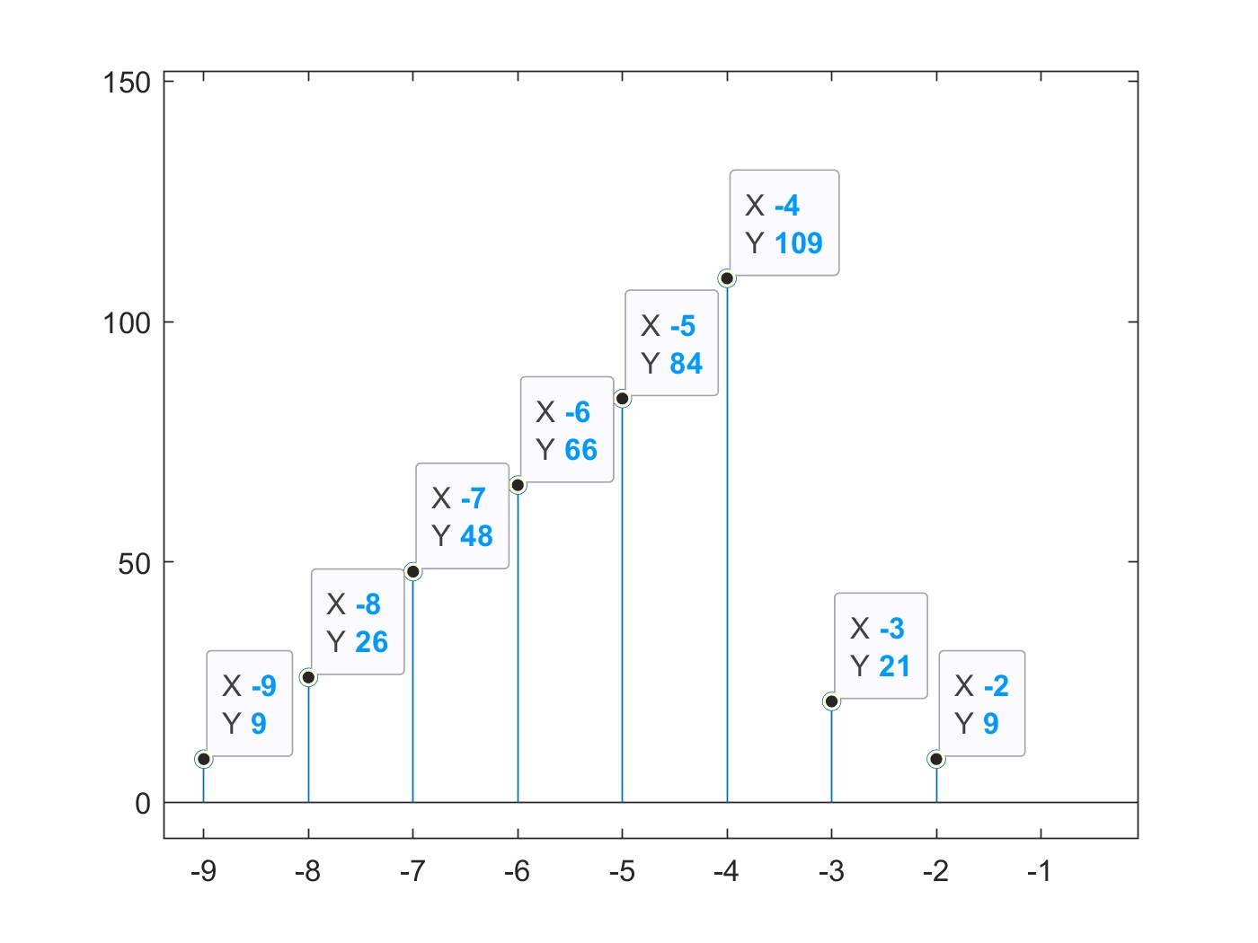

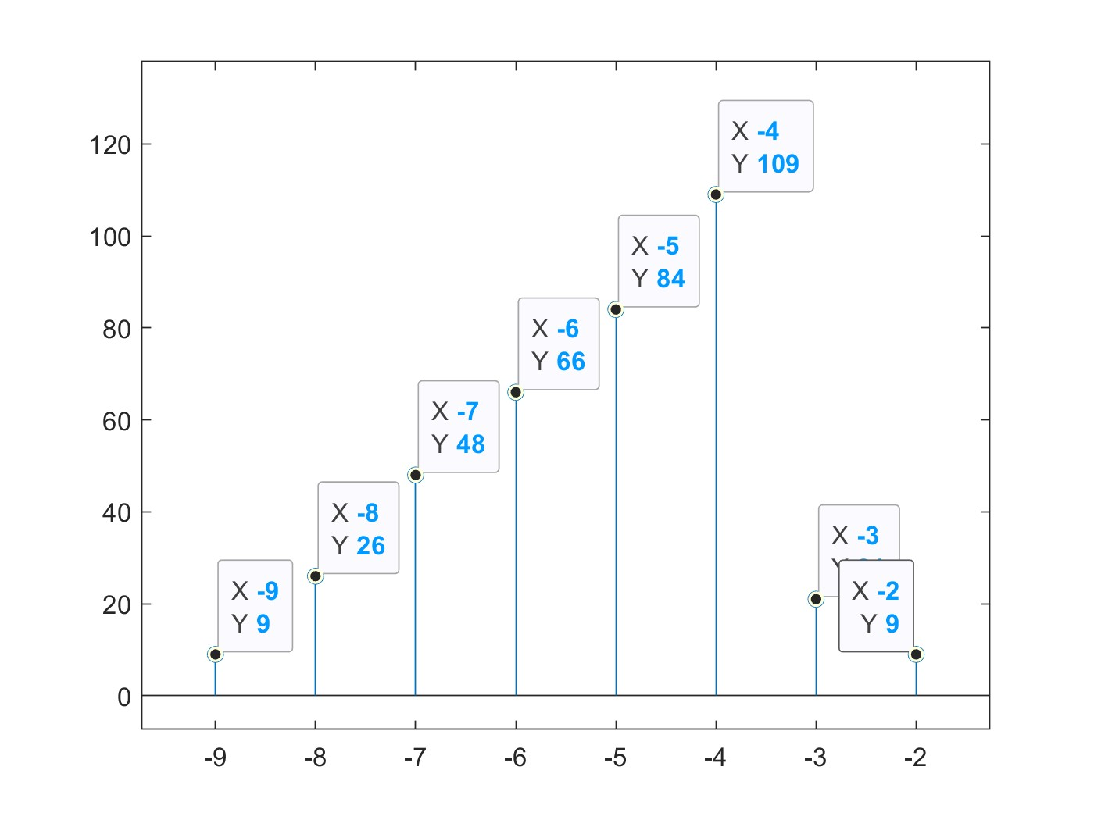
>> nx=[-3 -2 -1];
>> x =[1 2 3];
>> nh=[-6 -5 -4 -3 -2 -1];
>> h =[9 8 5 32 5 3];
>> M=length(x);
>> N=length(h);
>> ny=[-9:-2]
>> y=conv(x,h);

Student experiment 3:
- Inverse Fourier Series Code
function b=If_series(x)
N=length(x);
n=1:N;
b = zeros(1,N);
for k=1:N
b(k)=sum(x(k)*exp(-2*pi*i*k*n/N));
end

- Fourier series of the three signals:
- a_{k} = $\frac{1}{T}\int_{T}{x\left(t\right) e^{-jkωt} dt}$
- X(t) = $\sum_{-∞}^{∞}{a\left(k\right) e^{-jkωt}}$

X = [1 2 3 4]
Fourier Coefficient:
ak =

Columns 1 through 3

2.5000 + 0.0000i -0.5000 + 0.5000i -0.5000 - 0.0000i

Column 4

-0.5000 - 0.5000i

X signal:
Xt =

Columns 1 through 3

-0.0000 + 0.0000i 0.0000 - 0.0000i -0.0000 - 0.0000i

Column 4

-2.0000 - 2.0000i

X = [1 2 2 1]
Fourier Coefficient:
ak =

Columns 1 through 3

1.5000 + 0.0000i -0.2500 - 0.2500i 0.0000 - 0.0000i

Column 4

-0.2500 + 0.2500i

X signal:
Xt =

Columns 1 through 3

-0.0000 + 0.0000i 0.0000 + 0.0000i 0.0000 - 0.0000i

Column 4

-1.0000 + 1.0000i

X = [0 1 2 -2 -1]
Fourier Coefficient:
ak =

Columns 1 through 3

0.0000 + 0.0000i 0.0000 - 0.8507i -0.0000 + 0.5257i

Columns 4 through 5

0.0000 - 0.5257i -0.0000 + 0.8507i
X signal:
Xt =

Columns 1 through 3

0.0000 + 0.0000i 0.0000 + 0.0000i -0.0000 + 0.0000i

Columns 4 through 5

0.0000 - 0.0000i -0.0000 + 4.2533i

- Fourier series algorithm:

x[n]=cos(2*pi*n*3/7)
take point n = 0 as the start point then: $ω=2π*\frac{3}{7}$ , and since $T= \frac{2π}{ω}$ then T = $\frac{2π}{2π* \frac{3}{7}}= \frac{7}{3}$
then take n = [0 : 7/3]
Analytical solution:

$$\cos{(2πn*\frac{3}{7}} )→\frac{e^{\frac{6}{7}πnj}+ e^{-\frac{6}{7}πnj}}{2}$$
Then a_{o} = 0
a₆ = 0.5
a₋₆ = 0.5

Fourier series algorithm on MATLAB:
>> n = [0:0.1:7/3]
>> x = cos(2*pi*n*3/7)
>> ak = f_series(x);
>> ak
ak =

Columns 1 through 3

0.0278 + 0.0000i 0.5045 + 0.0441i -0.0098 - 0.0017i

Columns 4 through 6

-0.0035 - 0.0009i -0.0018 - 0.0006i -0.0011 - 0.0005i

Columns 7 through 9

-0.0007 - 0.0003i -0.0005 - 0.0003i -0.0003 - 0.0002i

Columns 10 through 12

-0.0003 - 0.0001i -0.0002 - 0.0001i -0.0002 - 0.0000i

Columns 13 through 15

-0.0002 - 0.0000i -0.0002 + 0.0000i -0.0002 + 0.0001i

Columns 16 through 18

-0.0003 + 0.0001i -0.0003 + 0.0002i -0.0005 + 0.0003i

Columns 19 through 21

-0.0007 + 0.0003i -0.0011 + 0.0005i -0.0018 + 0.0006i

Columns 22 through 24

-0.0035 + 0.0009i -0.0098 + 0.0017i 0.5045 - 0.0441i

x[n]= sin(2*pi*n*3/7)
take point n = 0 as the start point then: $ω=2π*\frac{3}{7}$ , and since $T= \frac{2π}{ω}$ then T = $\frac{2π}{2π* \frac{3}{7}}= \frac{7}{3}$
then take n = [0 : 7/3]
Analytical solution:

$$\cos{(2πn*\frac{3}{7}} )→\frac{e^{\frac{6}{7}πnj}- e^{-\frac{6}{7}πnj}}{2j}$$
Then a_{o} = 0
a₆ = 1/(2j)
a₋₆ = -1/(2j)

Fourier series algorithm on MATLAB:
>> n = [0:0.1:7/3]
>> x = sin(2*pi*n*3/7)
>> ak = f_series(x);
>> ak
ak =

Columns 1 through 3

-0.0012 + 0.0000i 0.0417 - 0.4905i -0.0046 + 0.0190i

Columns 4 through 6

-0.0041 + 0.0102i -0.0039 + 0.0069i -0.0038 + 0.0051i

Columns 7 through 9

-0.0038 + 0.0039i -0.0038 + 0.0029i -0.0038 + 0.0022i

Columns 10 through 12

-0.0038 + 0.0016i -0.0038 + 0.0010i -0.0038 + 0.0005i

Columns 13 through 15

-0.0038 + 0.0000i -0.0038 - 0.0005i -0.0038 - 0.0010i

Columns 16 through 18

-0.0038 - 0.0016i -0.0038 - 0.0022i -0.0038 - 0.0029i

Columns 19 through 21

-0.0038 - 0.0039i -0.0038 - 0.0051i -0.0039 - 0.0069i

Columns 22 through 24

-0.0041 - 0.0102i -0.0046 - 0.0190i 0.0417 + 0.4905i

x[n]= exp(j*2*pi*n*3/7)
take point n = 0 as the start point then: $ω=2π*\frac{3}{7}$ , and since $T= \frac{2π}{ω}$ then T = $\frac{2π}{2π* \frac{3}{7}}= \frac{7}{3}$
then take n = [0 : 7/3]
Analytical solution:

$$e^{j\frac{6}{7}πn}$$
Then a_{o} = 0
a₆ = 1

Fourier series algorithm on MATLAB:
>> n = [0:0.1:7/3]
>> x = exp(j*2*pi*n*3/7)
>> ak = f_series(x);
ak =

Columns 1 through 3

0.0278 - 0.0012i 0.9950 + 0.0858i -0.0288 - 0.0063i

Columns 4 through 6

-0.0138 - 0.0050i -0.0087 - 0.0045i -0.0062 - 0.0043i

Columns 7 through 9

-0.0046 - 0.0042i -0.0034 - 0.0041i -0.0025 - 0.0040i

Columns 10 through 12

-0.0018 - 0.0039i -0.0012 - 0.0039i -0.0007 - 0.0038i

Columns 13 through 15

-0.0002 - 0.0038i 0.0003 - 0.0037i 0.0008 - 0.0037i

Columns 16 through 18

0.0013 - 0.0036i 0.0019 - 0.0036i 0.0025 - 0.0035i

Columns 19 through 21

0.0032 - 0.0035i 0.0040 - 0.0034i 0.0051 - 0.0033i

Columns 22 through 24

0.0067 - 0.0031i 0.0092 - 0.0029i 0.0140 - 0.0025i

